# Question 3

To start this question, I copied question 2 and made a new folder called Q3. I removed all the .class files and ran the setup commands again to generate fresh tokens, antlr python3 files, and class files.

I noted down what was required to be modified from the question 2 codebase. The codebase had to be extended to have the ability to provide the top 10 of a file collection. It had to filter the list by biggest, smallest, oldest, or newest. A test case file had to be created to test these features to ensure that the language worked as intended.

## **Grammer**

To start, I added a new filter to the selfilter list:

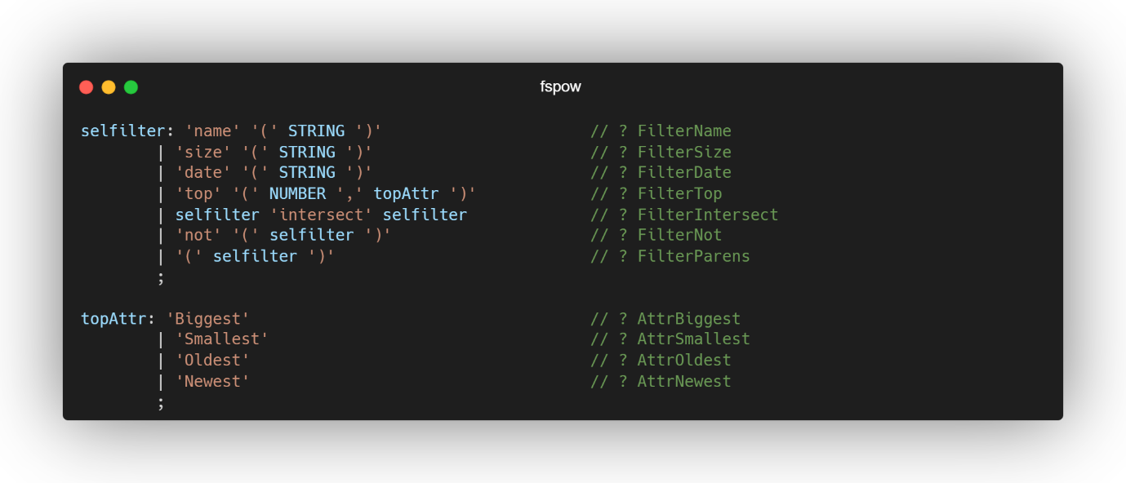

I added “top” as a filter. I allowed the filter to select a specific number (NUMBER) of files based on the attribute (topAttr). Where the NUMBER specifies how many files to select, and topAttr defines the attribute to use for the selection.

The addition of topAttr defines the attributes that can be used with the top filter. These attributes specify how the files should be ranked when selecting the top NUMBER of files. The options include:

1. Biggest: Selects the largest files by size.
2. Smallest: Selects the smallest files by size.
3. Oldest: Selects the oldest files by modification date.
4. Newest: Selects the newest files by modification date.

Some other changes I made to the fspow.g4 were adding a new Lexer rule for how commas are changed as I had some issues when running the grun command during testing.

COMMA: ',';